Project Report

Uncovering the Gaming Industry_s Hidden Gems A Comprehensive Analysis of Video Game Sales

* Introduction:
* Overview:

The aim of this data analysis is to understand what kind of games have been sold worldwide, trends in popularity and also to understand how different regions have their difference in trends and sales based on platforms ,game titles and publishers . The dataset here we use ia taken from kaggle and has been visualised using tableau and my summary and recommendations based on it.

* Purpose:
* In this report, we will be discussing the process of cleaning the data , analysis of data and visualization of the given data using the tableau from the year 1980 to 2016 .
* The main purpose of analyzing this video games sales is that there is a problem in predicting and understanding the success of a new game title in the market.
* The main use of this project is to analyze the dataset given by kaggle on video game sales by visualizing them and to understand in a better way .
* Here we can find the highest selling games using highest popularity in regions , bigger platforms, best game titles and popular publishers.
* Problem definition and Design thinking:
* Empathy map:

<https://drive.google.com/file/d/17WsoiHJhRlOBdVG9FIhQrAsGD8qDr_Lo/view?usp=share_link>

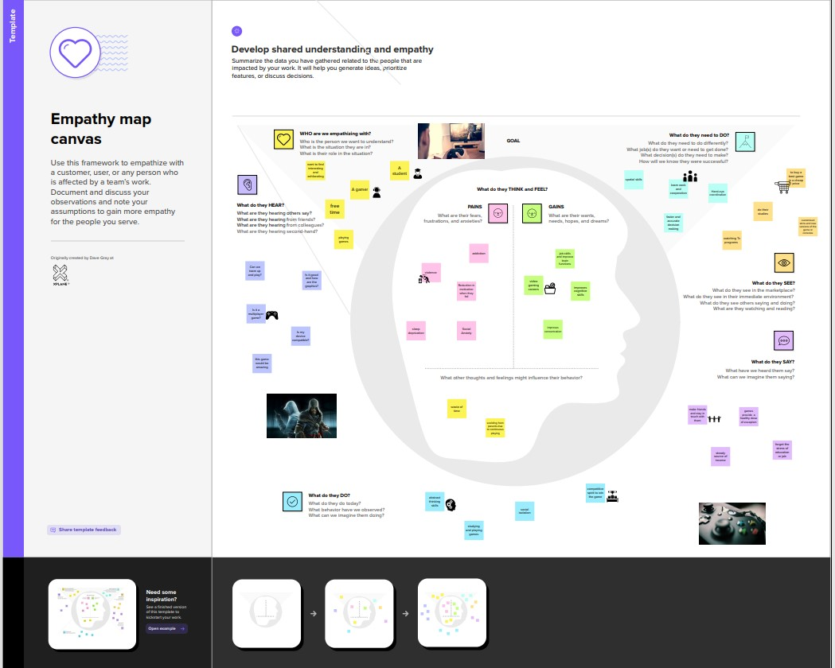

* Ideation and Brainstorming map:

https://drive.google.com/file/d/1uOTh9jAQc82vg7eh4RjSfgZF5N01cPR1/view?usp=sharing

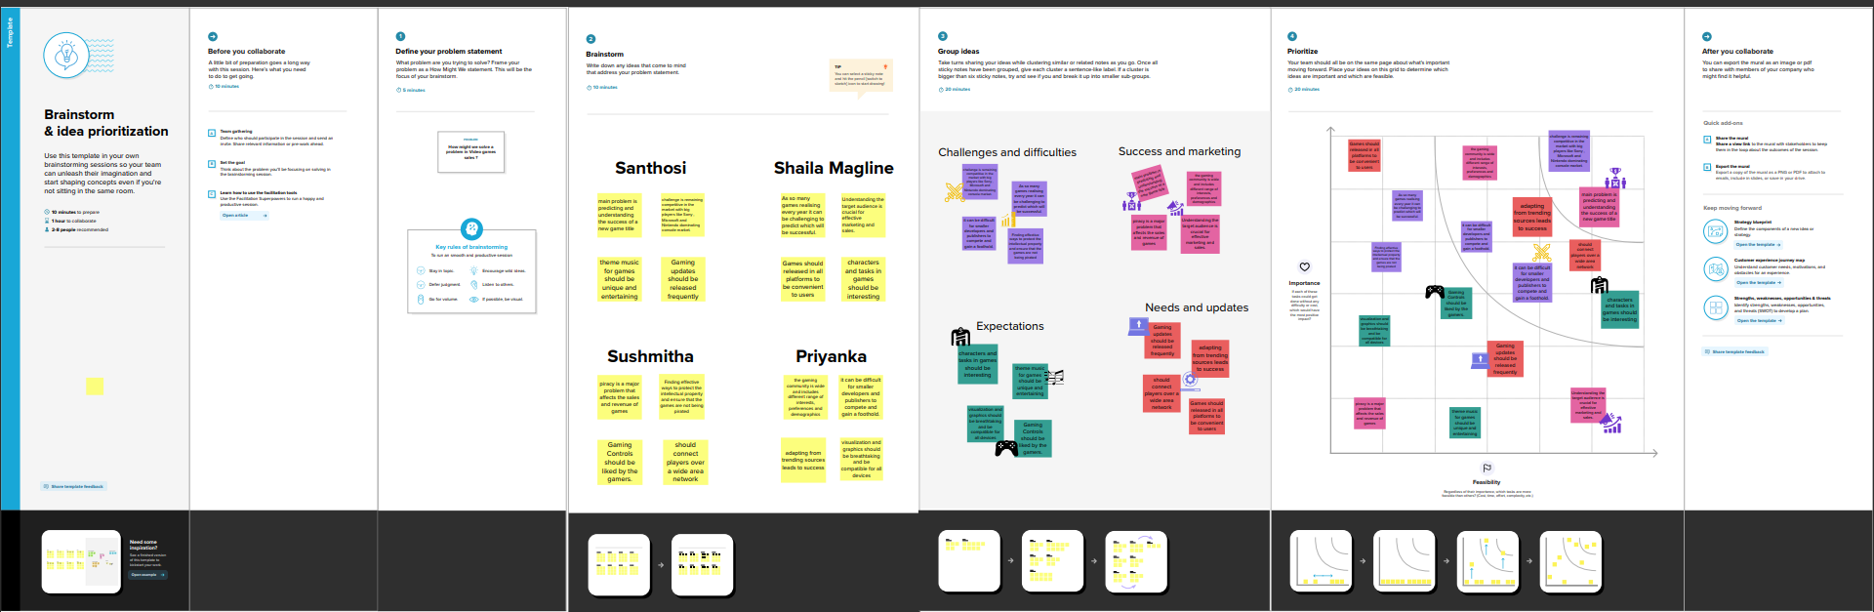

* Result:

The following results can be inferred from our project:

* from analyzing the sales based on game titles we have found out that Wii sports holds the first place in North america market with 82.74 million sales.
* Analyzing the sales based on publishers we have found out that Nintendo is the most popular among gamers with 1787 million sales
* Action genre based games is the most loved one by gamers around the world

These results were obtained by analyzing the dataset. Now to increase the video games sales are:

* Game title : Title should be based on genre that is most liked by the players and should be released in a comfortable platform.
* Genre vs Platform: When we analyzed Genre vs Platform we found that PC is the best platform and Action is the best genre to release a new game.
* Global sales: In 2008 the Global sales reached the height of 678.9 and it’s gradually decreasing year by year due to lack of interest .
* When we analyzed best 10 selling genre on platforms we found out that sports has the sales of 273.4 in PS2 platform.
* Wii sports is the top selling game in Europe market with 29.02 sales.
* Mario kart wii is the top selling in Japan market with 3.790 sales.
* Wii sports is the top selling game in North america with 41.49 sales.
* Dashboard:

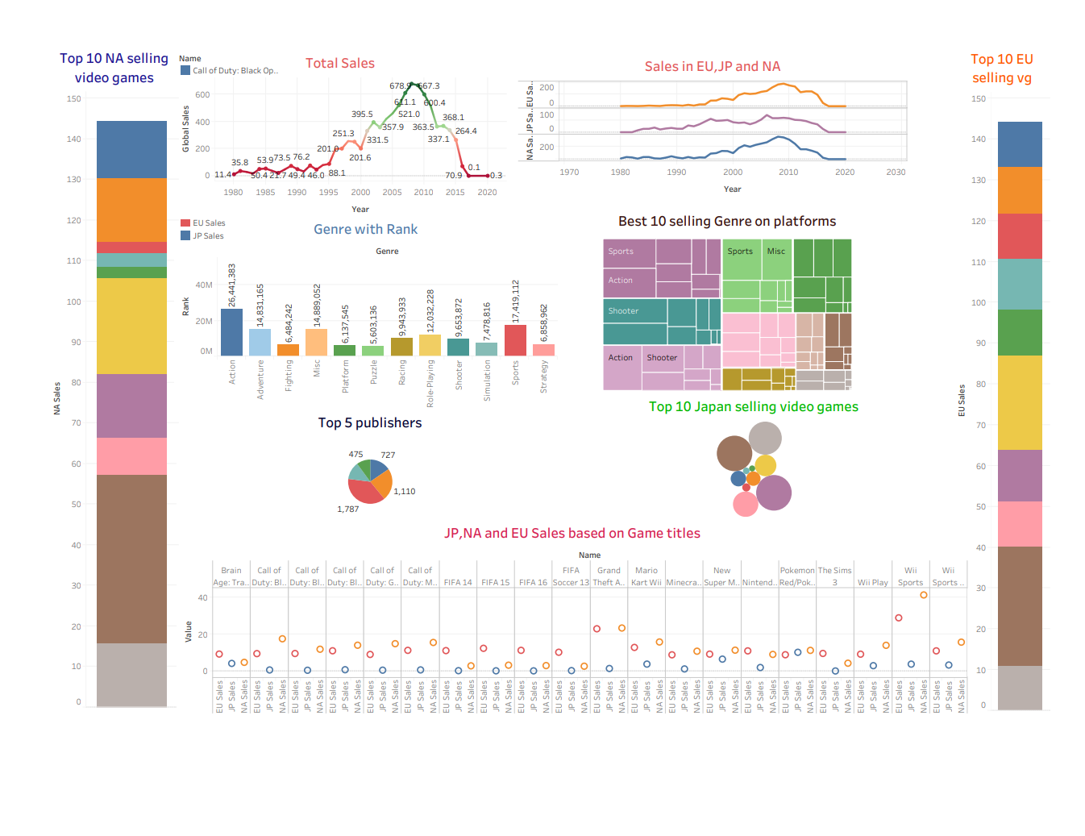

* Story

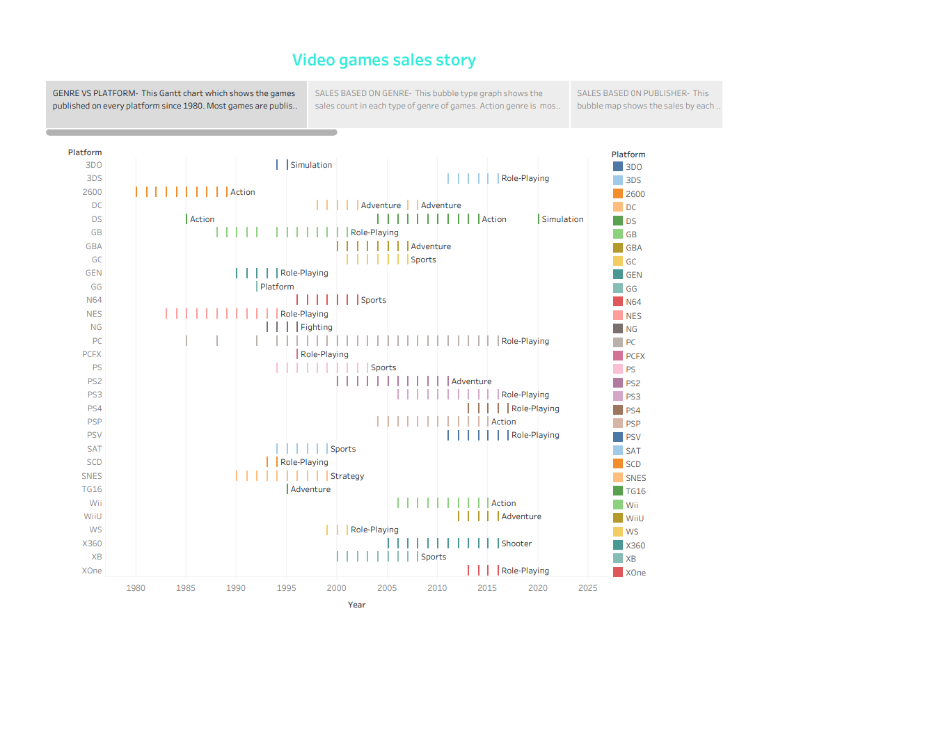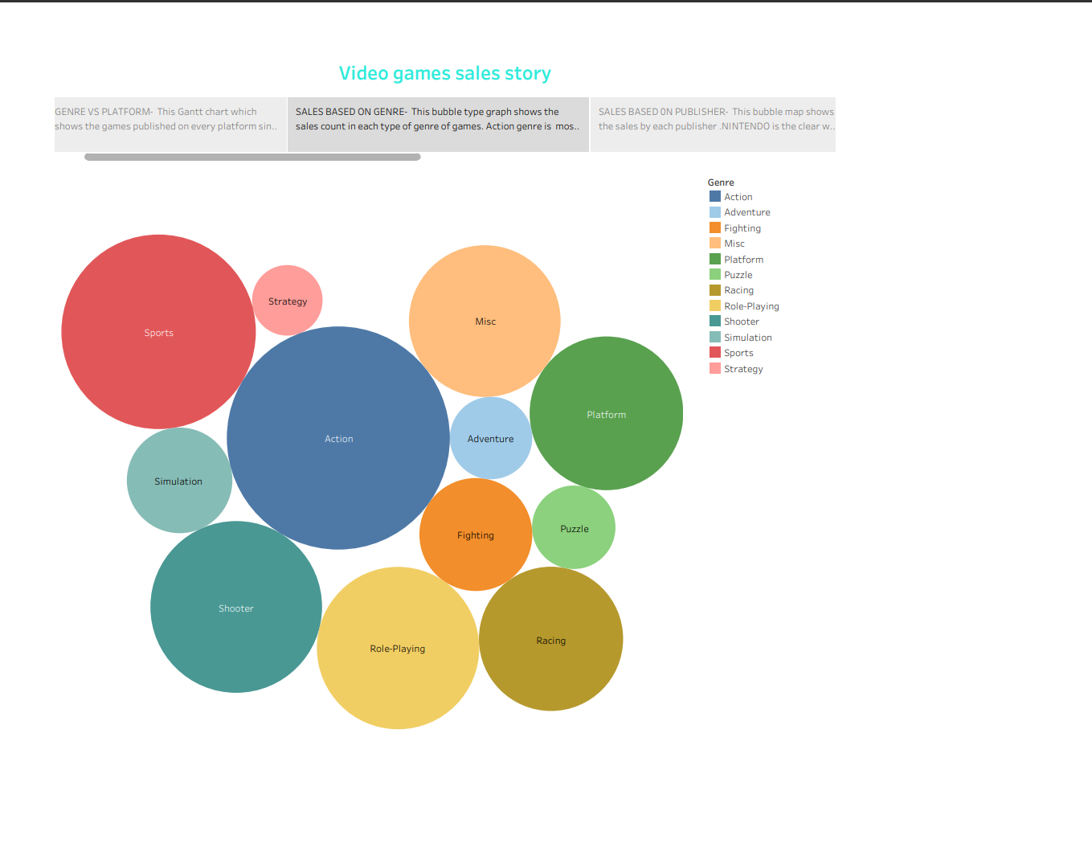

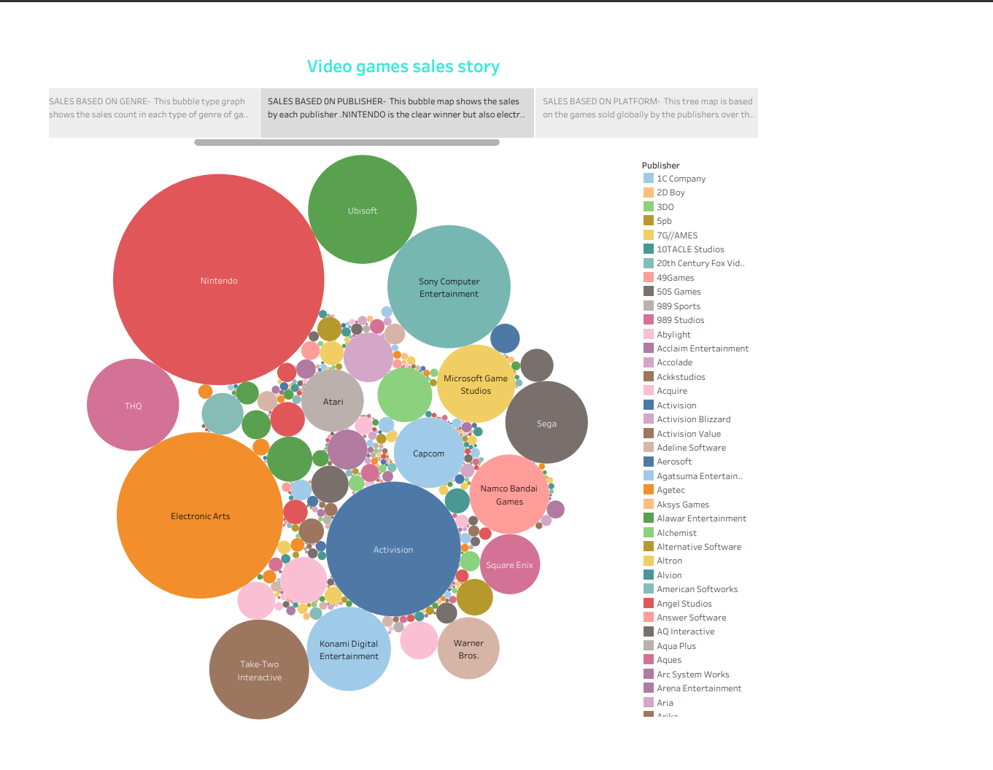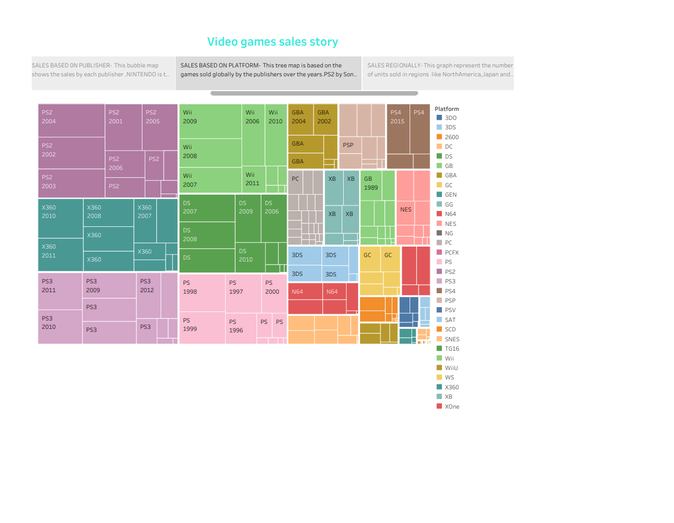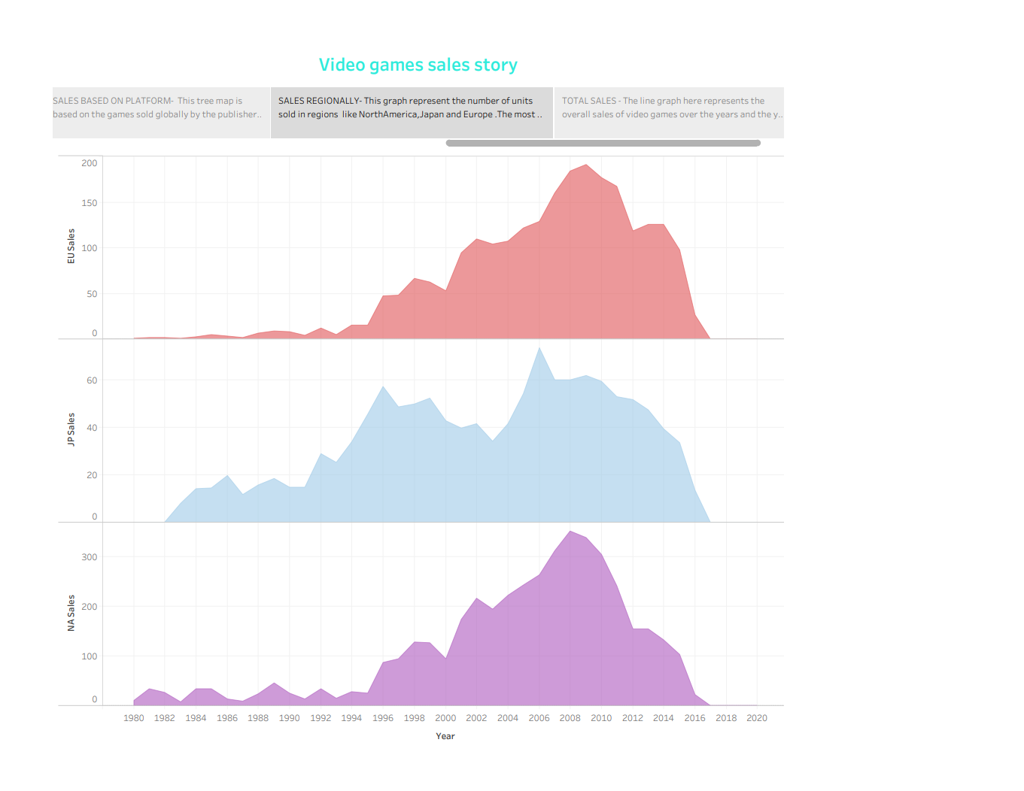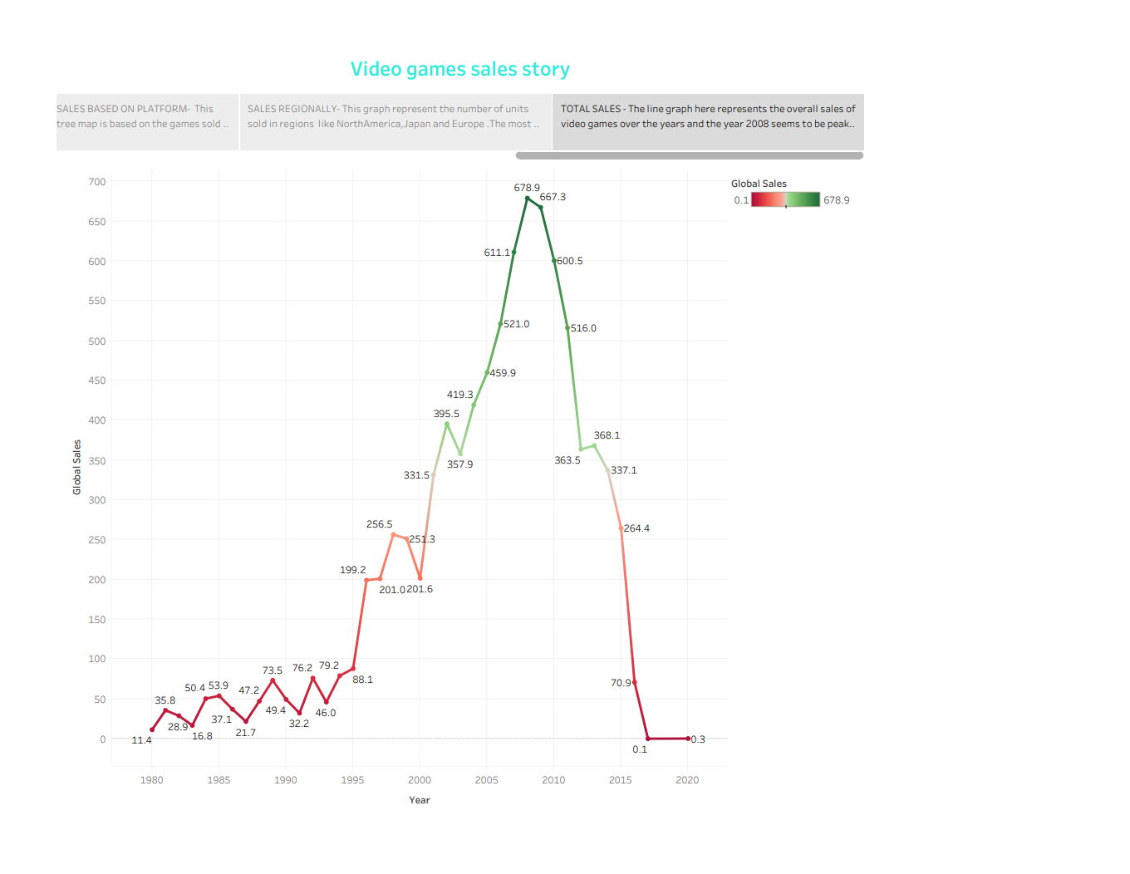

Business problems:

* Predicting and analyzing the success of new game title in the market.
* Remaining competitive in the market with big publishers like Sony entertainment system, Electronic arts , Rockstar games and Nintendo.
* Understanding the target audience is crucial.
* Piracy is a major problem in gaming industry affecting the sales and revenue of games.
* Advantages and Disadvantages:
* Game title:

Advantage - If the game titles are catchy to the gamers , then it will gain popularity among the gamers and other people and sales will be gradually increased.

Disadvantage - But some publishers copy the game titles, same game titles will affect the sales of a game.

* Genre vs Platform:

Advantage- Nowadays everybody from College to school students have their own Laptops or Desktops so releasing in PC and Action genre will increase the sales.

Disadvantage- Releasing games in the same platform would lead to extinction of other platforms like Playstation, Xbox and NES.

* Global sales:

Advantage- Advertising the games is the best in today’s world as people are more attracted to Advertisements and it will excite them to buy the games

Disadvantages - If video games got more popularity in the entertainment industry then other field like movies and drama will suffer great loss.

* Applications:
* The hypothesis of this thesis speculated that the effects of video games’ use in practical ways would be positive.
* While this can be true in many instances, the reality is that there are several problems associated with using video games beyond their intended use as entertainment.
* By using the analysis made, they can rectify the errors and make the new games to publish successfully.
* It can help future game creator by giving information about which genre the game should be and what platform it should be released to achieve high sales in market.
* It can also help for students to create a project regarding the Video games sales in a easy way.
* Game creators can easily identify the expectations of gamers and other people and can use it to create successful games.
* Conclusion:

As hardware generations have shifted in the past, we have seen players enter, leave, or even re-enter the market place. The timing is ripe for a new entrant into the market who understands both hardware and online delivery; such a player could be Apple. A lot remains to be seen in how the next generation will develop, but it is likely that this generation is deep into development and may not have accounted for online delivery.

Action games established themselves as the top genre over the past several decades, but whether that trend will continue indefinitely into the future is an open question. Japan, which is one of the largest single revenue regions, has a gaming culture built more around role-playing games and a large anime influence. This will likely continue to influence the popularity of particular titles, platforms, genres, etc. which cater more towards this sphere of the video game world.

* Future Scope:
* The future of the video game industry looks dazzling. Consumer demand is growing, technology is advancing quickly, and new monetization models are taking off. Analysis forecasts that global revenue for games could grow by more than 50% over the next five years
* The video game market is anticipated to have a prodigious CAGR of 12.9% during the forecast period of 2022-2032.
* The global video games market potential to generate income is predicted to be constrained by the expansion of free to play and cheap mobile and laptop games.
* One of the challenges faced by the video game market key participants is anticipated to be managing the cost and quality of video games.
* According to FMI, the video game market is expected to grow from US$ 195.65 billion in 2021 to US$ 743.21 billion by 2032.